Neerlandia
Eagle Express
Newsletter
December 2, 2021

As we enter another season of “pandemic advent'', it’s likely fair to say many are tired and exhausted from everything that has happened over the last couple of years.

Advent is supposed to be a season with a focus on hope, love, joy, and peace. Although these may feel scarce at times, they are still there. Like little mustard seeds that grow. Like yeast in the dough. That’s what the kingdom of heaven is like. The little subtle things that go unnoticed, yet make a big difference. How about a little, tiny, helpless baby that will change the world. That’s hope. Even in the darkness. Even when light is scarce.

Wishing you a blessed advent season and a Merry Christmas.

God bless,

Brett Seatter

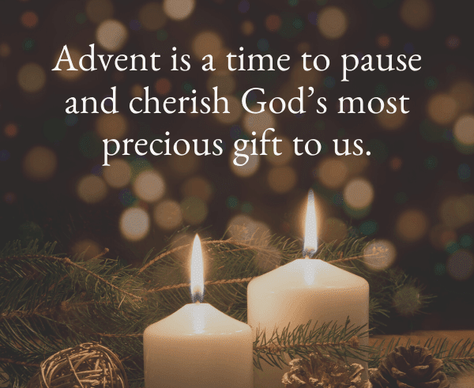

School Wide News:
St. Nick Day – Dec. 3

NPCS students will be celebrating St. Nick Day on Fri., Dec.3 in the afternoon.

St. Nicholas will be reading stories to the K (Tues/Thurs) & Gr 1 -Gr. 3 classes in the Foyer.

If time permits he will drop in and say “Hi” to the other classes.

Due to Covid regulations, we will NOT be able to have parents come into the school again this year. Our Jr. High Student Council has graciously offered to supply pizza for all of the students. Gift exchange will take place and each class will have fun games & activities throughout the afternoon.

CHRISTMAS CONCERT

- All K-Gr. 9 students will be going to the Neerlandia CRC for the concert on Tues., Dec. 14 (afternoon). We will be staying in our cohorts and will practice social distancing, etc.
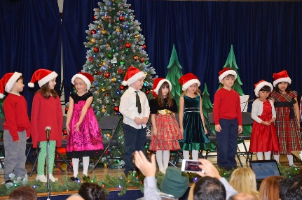
- This will be students only (no parents or community members) This will be recorded and will be available on You Tube before our Christmas Break.

We will be asking for donations for a worthy cause – most likely online giving but we are just working out the details and will let parents know via School Messenger over the next week or so.

Neerlandia Christian Education Society (NCES) News
The NCES board met on November 16, 2021. Here are the highlights of our meetings:
- Thank you to everyone who supported our November hot dog hot lunch!! A big thanks to our parent volunteers for making this possible: Charlene Fleming, Daniella Wierenga, Lindsay Pohl, Cass Krikke, Laura Braucht and Nicole Wierenga. Our next fundraiser will be a hot dog hot lunch on Thursday, January 20, 2022. Order forms will be sent out in early January. If you are available to help with this hot lunch, please contact Nicole Wierenga by text at 780-674-0874. Associate members are more than welcome to help with cooking hot lunches!! Please note that volunteers must comply with ANY Pembina Hills Public Schools COVID guidelines. At this time that requires showing proof of vaccination against COVID-19 or a negative COVID screening test within 72hrs of volunteering.

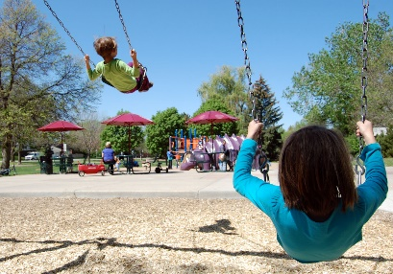
- Playground! We are still awaiting a grant decision for our application to provided matching funding for a zipline and swings. Charlene is also exploring other funding opportunities and getting drawing and quote to retrofit the existing grades 2-3 playground for wheelchair accessible play. We would like to thank Sandra Olthuis for volunteering to assist with the playground initiative. If anyone else is interested in assisting with this process, please text Charlene Fleming at 780-284-1534.

- A HUGE THANK YOU to the additional associate and family members who submitted their 2021-22 NCES membership fees in October and November! If you are still planning to submit a membership donation, please add the date of e-transfer and email address in the notes section. This will make our Treasurer’s job much easier.

- NCES newsletters. Many of you receive our newsletter through the Eagle Express circulated by the school or a printed copy in your Neerlandia CRC mailbox. The NCES newsletter is also emailed out to our membership on a monthly basis but we are missing many email addresses. If you would like to join the NCES email list, please send your email address to sheri.strydhorst@gmail.com.

- Preschool has been rolling for nearly 2 months. We have a real good group of students and parents. The NCES board would like to thank all our staff (Jessica Properzi, Ramona DeVries, and Nicole Wierenga) for working through the transition to a new location. The students did a special craft for Thanksgiving (October) and Remembrance Day (November). The students are enjoying special crafts, reviewing the day’s weather, reading books, singing songs and playing outside. We would ask that any preschool parents who have not signed up for the “What’s App” preschool chat group to please do so, ASAP as this is the communication tool used by the program for important information and updates.

- Possible Preschool Student Subsidy. Some children may be eligible for a new Government of Alberta subsidy to partially reimburse parents for their preschool fees. As of November 15, there was a new announcement that applies to preschool. All parents of NCES preschool students are welcome to go to the website https://applychildcaresubsidy.alberta.ca, and fill out the form. Parents will be assessed if they qualify or not. If they do qualify, they will automatically be added to our claims file.

- You are welcome to join our next NPCSC and NCES board meeting scheduled for January 17, 2022.
On behalf of the 2021-22 NCES board: Sheri Strydhorst, Charlene Fleming, Annemiek Elzinga, Amanda Batty, Kym Peters, Laura Braucht, Nicole Wierenga and Geraldine Wierenga
PHSD BOARD NEWS

COVID19 UPDATE
There are currently active cases in our schools. When a school is placed into “alert” or “outbreak status”, they remain on that status for quite some time before being removed – 14 days following the last active case.
AHS has also initiated a change in their notifications process regarding COVID cases in schools – AHS now emails Assistant Superintendent Mark Thiesen with any case information (student of staff), then we send out a template notification of exposure to affected staff and students.
We continue to monitor student attendance – when absences within any school or class go above 10%, AHS will follow up by determining the cause of those absences; we adhere to their guidance. For instance, a few early learning classes have had students not show up due to illness- AHS has notified and they followed up. More recently we’ve seen respiratory illnesses crop up in our schools, but COVID doesn’t appear to have been the cause of these absences.

VACCINATION POLICY
Earlier in October, the board received a joint letter from the Ministers of Health and Education encouraging school boards to require staff to either provide proof of vaccination against COVID-19 or provide negative screening tests. The board received several comments from staff and community members, and reviewed current year statistics on lost time for staff as well as infection rates for staff and students.
COVID19 Hazard Control Vaccination Status was Implemented for staff on November 1, 2021. This AP requires employees, contractors or volunteers (inside or outside) to provide proof of vaccination prior to November 26th, and if employees are not fully vaccinated they are required to provide negative screening tests no more than 72 hours prior to any shift. Of responses received, 98.6% are fully vaccinated.

FOOD & BEVERAGES
Division-provided food and beverages for events and meetings -In early 2020, the Board of Trustees passed a motion to eliminate all food and beverage spending for division, school and board events and meetings. While this action was taken to relieve budget pressures and was necessary at that time, the division’s situation has changed. The newly-elected board recognized that while budget concerns will always be top of mind, they must be balanced by operational considerations, including the ability for staff to network and host external stakeholders.
As a result, the board rescinded this motion, which will once again allow for expenditures for food and beverages at events and meetings.
ASBA – FGM
Trustees spent 3 days in Edmonton for the ASBA FGM…. We were giving suggestions on how they can improve the curriculum, it was at the top of discussion. They have received our feedback, we are taking a more collaborative approach instead of attacking the curriculum in its entirety… The government is going through with the new curriculum, what we have control of – is how we approach the government with our ideas on how and where to change the content being taught.
Another hot topic for the FGM is the increased busing transportation insurance costs… where we have passed a resolution on our position to lobby the province for new funding for offset the insurance costs for busing.
I wanted to also wish everybody at NCPS a Very Very Merry Christmas! I'm very much looking forward to meeting more of you at the Parent Council meeting on January 17 @ 6:30pm.

Victoria Kane
Vice Chair, Trustee
Pembina Hills West Ward victoria.kane@pembinahills.ca C 403.478.4260

SPORTS
Elementary Volleyball:
The Gr. 5/6 volleyball players will be finishing up their short season with a final tournament at the Westlock Spirit Centre on Thursday, Dec. 2.
Thanks to Mr. Brent Wierenga & Mr. Steve De Vries for coaching this team.
JR. HIGH BASKETBALL
Jr. High Basketball season has begun. We will have two Girls teams (Gr. 7/8 & 8/9). Mr. Seatter & Marlea Seatter will coach the Gr. 8/9 girls’ team and Ms. Toni Liber (K teacher) will coach the Gr. 7/8 girls’ team. Mrs. Miranda Strydhorst & Mr. Cody Cooper will coach the Gr. 7-9 Boys team. Girls will practice on Mondays & Wednesdays: Gr. 7/8 at 3:45 – 4:45 and Gr. 8/9 from 3:45 – 5:30. The boys will practice from 3:45 – 5:15 pm on Tues. & Thurs. The schedules for games & tournaments have been sent home with the players.

LIBRARY NEWS
December Library Hours
Monday-Thursday
9:00AM-4:30PM
All Day Friday, December 3
9:00AM-4:30PM
Library Closed for Christmas Break
December 17-January 2
Library will be open 2 days during the break
Thursday, December 23 and Thursday, December 30
9:00AM-4:30PM

Gift Card Fundraiser
We made $765.05. That has to be a record! Thanks to everyone who continues to support this fundraiser! Gift cards are available for pick up (arrived on Tuesday, November 30).

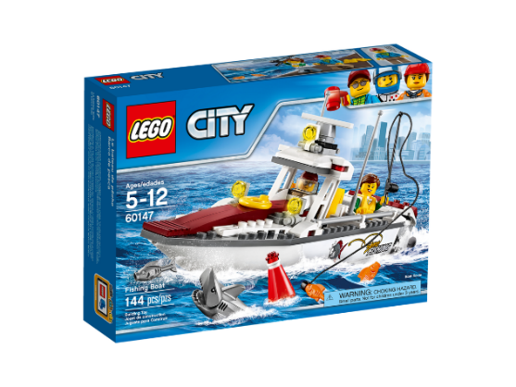
Lego-Building Contest will be held Thursday, January 20, 2022.
Theme: “My Favorite Place”
Registration forms are available at the library and should be handed in by Monday, January 10.


CALENDAR OF EVENTS

Dec. 3, p.m. – St. Nick’s Day celebrations in the afternoon
Dec. 10 – Alternate Day
Dec. 14 – Christmas Concert live (You Tube available by Dec. 16)
Dec. 16 – last day of classes for 2021
Dec. 17 – Alternate Day
Dec. 17, 2021 – Jan. 3, 2022: Christmas Break

Have a Blessed Christmas!



